**06. Develop a lexical analyzer to identify identifiers, constants, operators using C program**

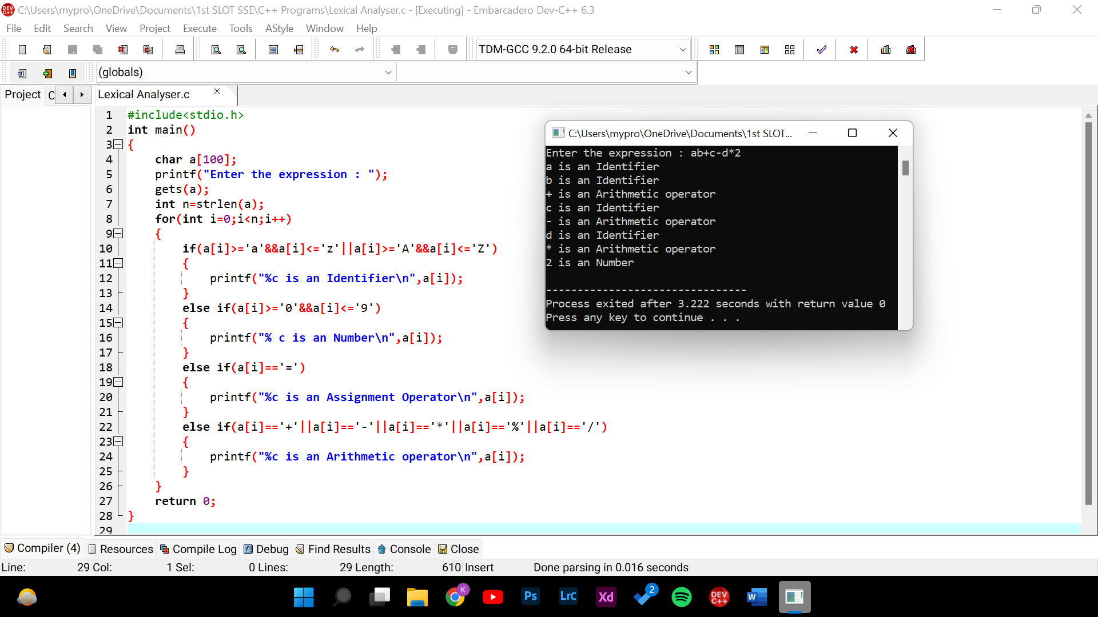

**Source Code :**

#include<stdio.h>

int main()

{

char a[100];

printf("Enter the expression : ");

gets(a);

int n=strlen(a);

for(int i=0;i<n;i++)

{

if(a[i]>='a'&&a[i]<='z'||a[i]>='A'&&a[i]<='Z')

{

printf("%c is an Identifier\n",a[i]);

}

else if(a[i]>='0'&&a[i]<='9')

{

printf("% c is an Number\n",a[i]);

}

else if(a[i]=='=')

{

printf("%c is an Assignment Operator\n",a[i]);

}

else if(a[i]=='+'||a[i]=='-'||a[i]=='*'||a[i]=='%'||a[i]=='/')

{

printf("%c is an Arithmetic operator\n",a[i]);

}

}

return 0;

}